**Đỗ Thế Phi – SE161229 – SE1740 – OSG202**

**Chapter 2. Processes and Thread**

1. What is Processes ? Give an illustrative example.

**Process is the sequence (order, manner) of performing an activity that has been prescribed, mandatory, and meets the specific objectives of administrative activities (management and governance). These activities include all forms of activities (or processes) in the social life of people, such as production, business, service, training, research, religious activities. , art, war. Processes appear common in the existence and development of all things, such as the process of weaving webs of spiders, nesting of birds or hunting of tigers....**

**\*Example :**

**The company needs to hire a qualified person for the position of product manager**

**1. First, the HR manager will post an advertisement on a job portal**

**2. After receiving the required number of applications, an individual in the team will contact interested candidates and ask them to come for an interview.**

**3. An interview will be conducted in which the candidates must pass many rounds to secure the job position.**

**4. The most suitable candidate will be selected based on the predefined score and passing expectation.**

**5. Human resource manager will let selected candidates sign some necessary documents and certain contracts.**

**6. Selected candidates will be trained by assigned trainers based on job requirements.**

**7. After that, new employees are given tools, company brochure and necessary documents to start work.**

**This process will be repeated in a standardized and optimized way whenever the company needs to hire a new employee.**



1. What is Threads ? Give an illustrative example

**In computer science, a thread of execution is the smallest sequence of programmed instructions that can be managed independently by a scheduler, which is typically a part of the operating system. The implementation of threads and processes differs between operating systems, but in most cases a thread is a component of a process.**

**\*Example :**

**On the Internet in USENET newsgroups and similar forums, a thread is a sequence of responses to an initial message posting. This enables you to follow or join an individual discussion in a newsgroup from among the many that may be there. A thread is usually shown graphically as an inital message and successive messages "hung off" the original message. As a newsgroup user, you contribute to a thread by specifying a "Reference" topic as part of your message.**

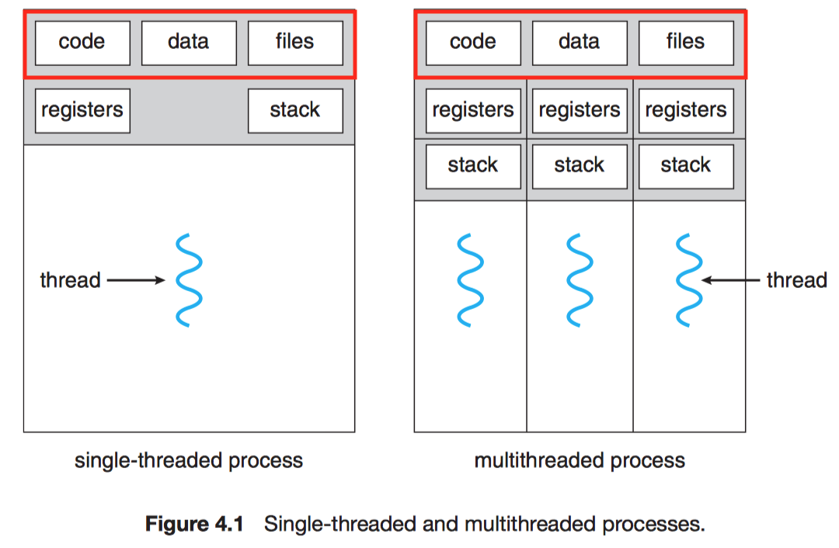

1. What is the PCB ?

**PCB fabrication is the process or procedure that transforms a circuit board design into a physical structure based upon the specifications provided in the design package. This physical manifestation is achieved through the following actions or techniques:**

**Imaging desired layout on copper clad laminates**

**Etching or removing excess copper from inner layers to reveal traces and pads**

**Creating the PCB layer stackup by laminating (heating and pressing) board materials at high temperatures**

**Drilling holes for mounting holes, through hole pins and vias**

**Etching or removing excess copper from the surface layer(s) to reveal traces and pads**

**Plating pin holes and via holes**

**Adding protective coating to surface or solder masking**

**Silkscreen printing reference and polarity indicators, logos or other markings on the surface**

**Optionally, a finish may be added to copper areas of surface.**

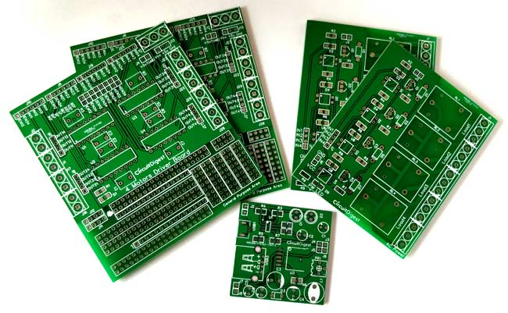

1. What is the IPC ?

**Interprocess communication (IPC) is a set of programming interfaces that allow a programmer to coordinate activities among different program processes that can run concurrently in an operating system. This allows a program to handle many user requests at the same time.**

